# ICA 4.4 Module 4 ICA

**H. Diana McSpadden - hdm5s**

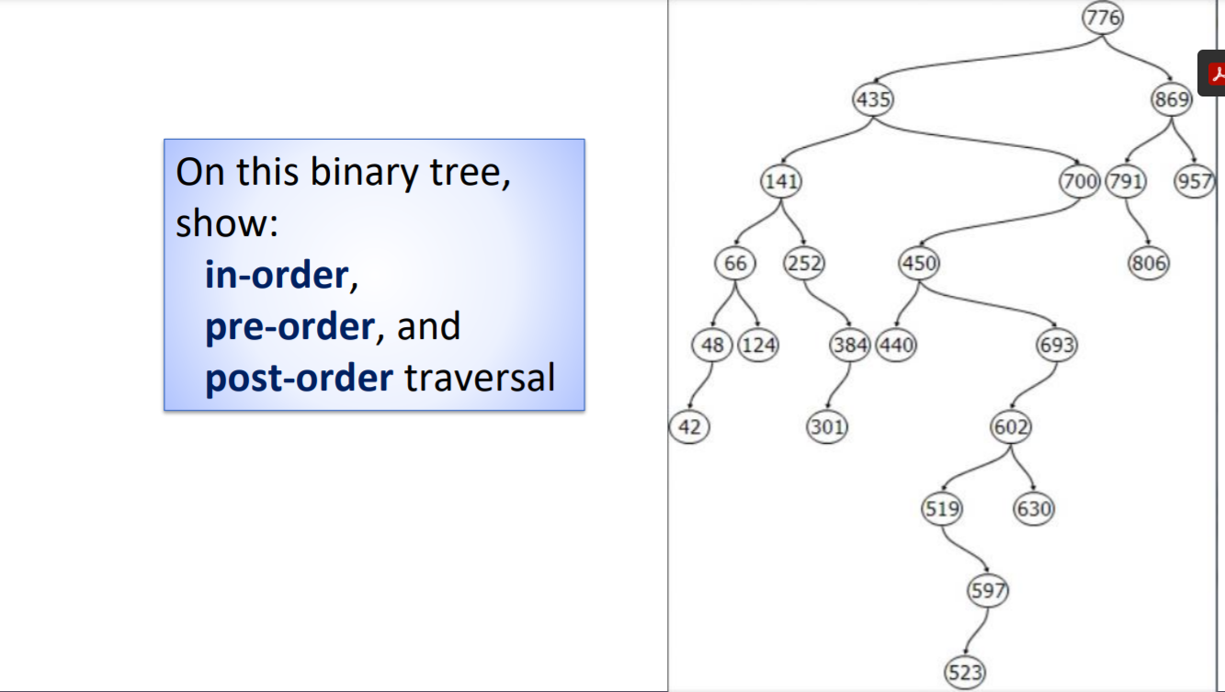

**Pre**: 776, 435, 141, 66, 48, 42, 124, 252, 384, 301, 700, 450, 440, 693, 602, 519, 597, 523, 630, 869, 791 ,806, 957

**In Order**: 42, 48, 66, 124, 141, 252, 301, 384, 435, 440, 450, 519, 523, 597, 602, 630, 693, 700, 776, 791, 806, 869, 957

**Post**: 42, 48, 124, 66, 301, 384, 252, 141, 440, 523, 597, 519, 630, 602, 693, 450, 700, 435, 806, 791, 957, 869, 776